Cairo University  
Faculty of Computers and Information



**CS251**

**Software Engineering I**

X-Game

Software Design

Fci-Team

December& 2016

Contents

Team 3

Document Purpose and Audience 3

System Models 4

I. Class diagrams 4,5

Important Algorithm 5

II. Sequence diagrams 6

Class - Sequence Usage Table 9

Ownership Report 9

# Team

|  |  |  |  |
| --- | --- | --- | --- |
| **ID** | **Name** | **E-MAIL** | **Mobile** |
| **20140266** | **Mostafa Saied Hanfy Abd EL-Hamed** | [**m.saied@stud.fci-cu.edu.eg**](mailto:m.saied@stud.fci-cu.edu.eg) | **01114621369** |
| **20140188** | **Omar Mohamed Hussein Mohamed** | **Omar_wahba2@yahoo.com** | **01276319343** |
| **20140269** | **Mostafa Mahfouz Said** | **Mostafa.sayed784@yahoo.com** | **01118721121** |
| **20140145** | **Soliman Gamaa Mohamed** | **Solimangamea@gmail.com** | **01112270833** |

# 

# Document Purpose and Audience

**This document describes software requirements for educational website; it is intended for the team that will develop this website.**

**System Models**

**I. Class diagrams** 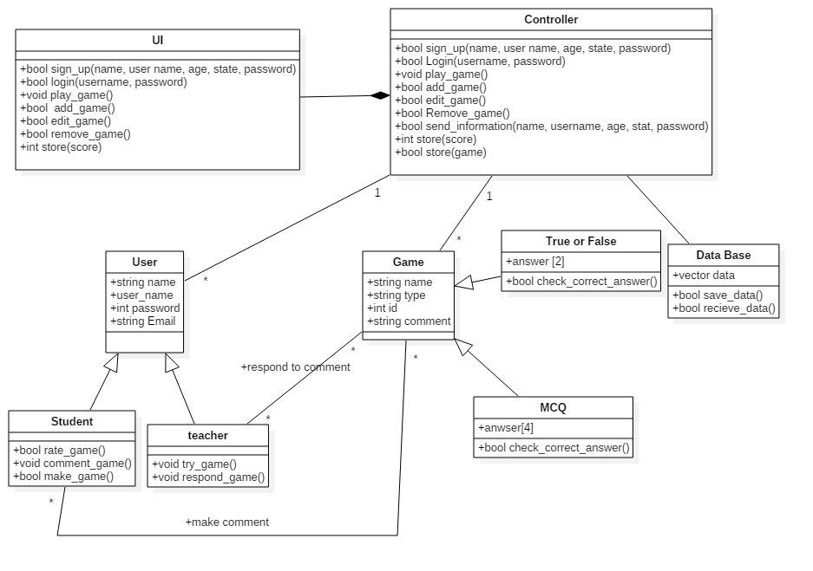

### 

| **Class ID** | **Class Name** | **Description & Responsibility** |
| --- | --- | --- |
| **1** | **Controller** | **Control other classes and methods** |
| **2** | **User interface** | **Interaction with user** |
| **3** | **Game** | **Game properties** |
| **4** | **True or false** | **Type of game** |
| **5** | **MCQ** | **Type of gam** |
| **6** | **Database** | **Store date** |
| **7** | **user** | **User properties** |
| **8** | **student** | **Student properties and methods** |
| **9** | **Teacher** | **Teacher properties and methods** |

### Important Algorithm

**None** **exist.**

## 

## II. Sequence diagrams

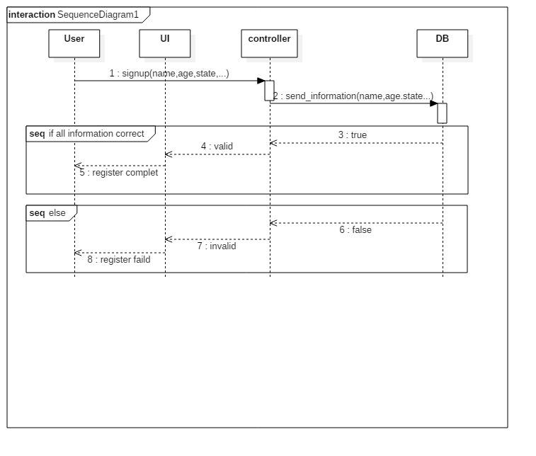

### 

### 

### Class - Sequence Usage Table

| **Class Name** | **Sequence Diagrams** | **Overall used methods** |
| --- | --- | --- |
| User | 1 (sign up) | Send_information() |
| Teacher | 2 (add game) | Login(),send(),addgame(),store(), |
| Student or teacher | 3 (play game) | Login(),send_information(),  playGame(),store() |

**Ownership Report**

|  |  |
| --- | --- |
| **Item** | **Owner** |
| Class diagrams | Omar Mohamed, Soliman Gamaa, Mostafa Mahfouz, Mostafa Saied |
| Sequence diagrams | Omar Mohamed, Soliman Gamaa, Mostafa Mahfouz, Mostafa Saied |